

**MATHEMATICS**

**Specialist Units 3 & 4**

**Test 5 – Applications of Differentiation and Differential Equations**

**Chapters 12 and 16**

**Semester 2 2017**

# 

**Section Two – Calculator Assumed**

Time allowed for this section

Working time for this section: 40 minutes

Marks available: 38 marks

## Material required/recommended for this section

##### To be provided by the supervisor

This Question/Answer booklet

Formula sheet

##### To be provided by the candidate

Standard items: pens, pencils, pencil sharpener, eraser, correction fluid, ruler, highlighters

Special items: drawing instruments, templates, notes on one unfolded sheet of A4 paper, and up to three calculators satisfying the conditions set by the Curriculum Council for this course.

## Important note to candidates

No other items may be used in this section of the examination. It is **your** responsibility to ensure that you do not have any unauthorised notes or other items of a non-personal nature in the examination room. If you have any unauthorised material with you, hand it to the supervisor **before** reading any further.

1. (8 marks)  
   A particle P is projected from the top of a cliff of height 100 m. Define *x* and *y* metres as the horizontal and vertical distance travelled by the particle measured from the base of the cliff after *t* seconds.

Its equation of motion at any time t seconds is given by $\frac{dx}{dt}=20\sqrt{2}$ and $\frac{dy}{dt}=20\sqrt{2}-10t$.

1. Determine the equation of the horizontal distance travelled by the particle after *t* seconds. [1]
2. Determine the equation of the vertical distance travelled by the particle after t seconds. [2]
3. The equation of the path of P is given by $y=ax^{2}+bx+c$. Determine *a*, *b* and *c*. [3]
4. Determine, using calculus methods, the approximate change in the vertical distance when the horizontal distance changes from 10m to 10.1m. [2]
5. 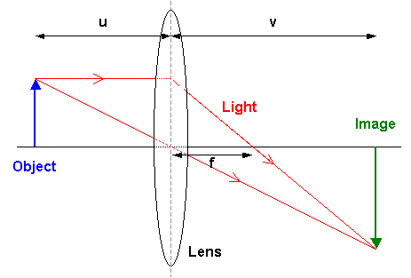(4 marks)  
   When an object is at a distance of *u* cm from a lens of focal length, *f =* 20 cm, an image is created at a distance of *v* cm from the lens.

The variables are related by the formula $\frac{1}{20}=\frac{1}{u}+\frac{1}{v}$

An object is moving with a constant speed of 2 cm/s

towards the lens. At the instant when the image is

30 cm from the lens, in what direction and with

what speed is the image moving?

1. (3 marks)

A leaking water tank initially contains water to a depth of 1.6m. The depth of water,

*h* cm, is decreasing at a rate (in cm/s) equal to one tenth of the depth of the water in the tank.

1. Write a differential equation that describes the rate of change of the depth of the water in relation to the depth. [1]

1. Determine the solution to the differential equation and calculate, to the nearest tenth of a second, the time taken for the depth to decrease to just 5 cm. [2]

1. (8 marks)  
   The motion of a body moving in a straight line is modelled by the differential equation $\frac{dx}{dt}=3+4x$, where *x* metres is the displacement from a fixed point at time *t* seconds for

*t* ≥ 0. After 1 second the body is 2m to the right of the origin.

1. What is the acceleration of the body when *t* = 1s? [3]
2. Show that the displacement is given by $x=\frac{11e^{4t-4}-3}{4}$. [5]
3. (9 marks)  
   The population *P* of a colony of marsupials at a remote island is currently 20. The colony’s expected growth rate is given by $\frac{dP}{dt}=0.1P(1-\frac{P}{200})$, where *t* is in years.
4. By separation of variables and use of partial fractions express P as a function of *t*, in the form $P=\frac{A}{1+Be^{-kt}}$ [7]
5. Determine the time it takes for the population to reach half its limiting value. [2]
6. (6 marks)  
   A light is positioned at the top of a vertical post 12m high. A small ball is dropped vertically from the same height as the light but at a point 4m away. The vertical distance travelled by the ball *t* seconds after release is given by $4.9t^{2}$.

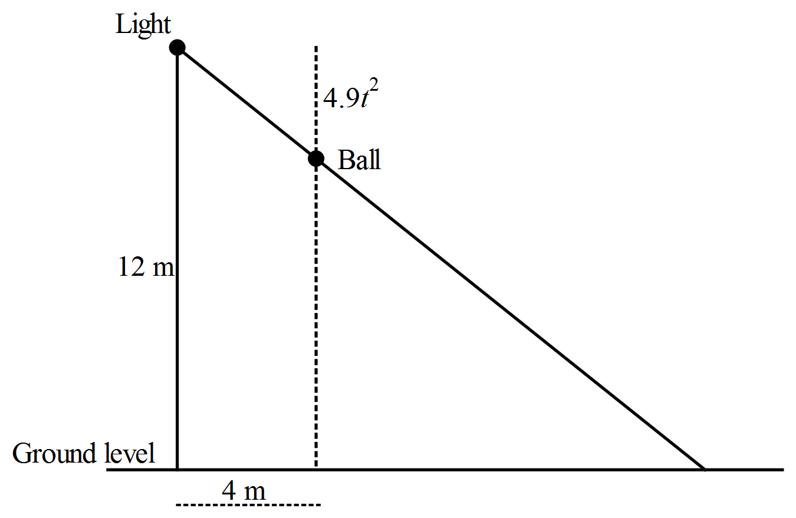

How fast is the shadow of the ball moving along the horizontal ground half a second after the ball is dropped?

**End of Section Two**

**This page has intentionally been left blank**

You may use this space to extend or re-attempt an answer to a question or questions and should you do so then number the question(s) attempted and cross out any previous unwanted working.